**Manual Hypothesis Testing with PSD-based Labels**

*In this document we summarize the efforts to evaluate Morris’s hypothesis for correlation of fine structure pattern of spectral band 0-7Hz to a metabolic-glycemic states, recorded for Insulin-Dependent patients 1-to-10*

We can summarize Morris’s hypothesis as follows:  
0. Baseline (Fasting): Dominant 0-1Hz, broad peak, stable amplitude  
1. After_First_Insulin: Broadened low-freq peak, extra peaks 2-5Hz, lower amplitude  
2. Peak_Hypoglycemia: Distinct high-frequency peaks  
3. After_Ensure: Narrow peak, clean spectrum, minimal activity above 1Hz  
4. After_Second_Insulin: Mixed pattern - high low-freq peak + shallow 2-5Hz peaks

Scope of study:

**Data Extraction & Preprocessing** (same as done before)

- Loading preprocessed signals and labeled events from the patient datasets

- Mapping basic states to specific hypothesis states.

- Adding glycemic classification based on glucose levels (<70mg/dL = hypoglycemia)

- Creating combined metabolic/glycemic states to capture full metabolic context

**Spectral Analysis Implementation**

- We have extracted multiple 4-second signal segments from each metabolic/glycemic state

- Applied Welch's method for PSD calculation with consistent parameters

- Focused our analysis on the 0-7Hz frequency range with custom sub-bands

- Averaged PSDs across multiple segments to ensure statistical robustness

**Hypothesis Testing Framework**

For each metabolic/glycemic state, specific criteria (quasi-metrics) are quantitatively evaluated following Morris’s hypothesis, as it was based on visual findings during the experiment and, documented in the file event pics descriptions.doc and summarized as follows:

*“Baseline” (Fasting)*

- Dominant low-frequency peak (0-1Hz range)

- Peak width and stability measurements

- Relative power distribution across frequency bands

*“After First Insulin”*

- Low-frequency peak width comparison against baseline

- Detection of secondary peaks in 2-5Hz range

- Amplitude reduction measurement

*“Peak Hypoglycemia”*

- High-frequency component identification

- Rhythmicity quantification via autocorrelation

- Peak count and frequency distribution

*“After Ensure”*

- Peak narrowness and spectral purity metrics

- Power ratio calculations between frequency bands

- Quantification of activity above 1Hz threshold

*“After Second Insulin”*

- Mixed pattern signature detection

- Power distribution across low and mid-frequency bands

**Direct patient-specific results:**

On the following charts one may see the fine structure of spectral band 0-7Hz, extracted following the procedure described above.

Lines on the chart correspond to the statistical means of metabolic/glycemic state regions and shaded areas represent the variance of these variables across the sampled sequences.

High-resolution charts are available outside of the scope of this summary as separate image files.

We will group the charts per channel/per patient (30 charts in total):

***Hand channel:***

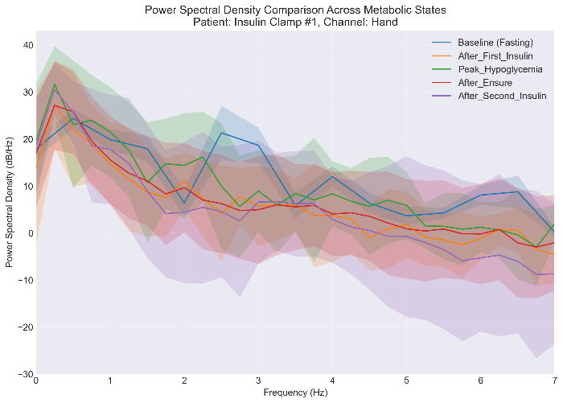

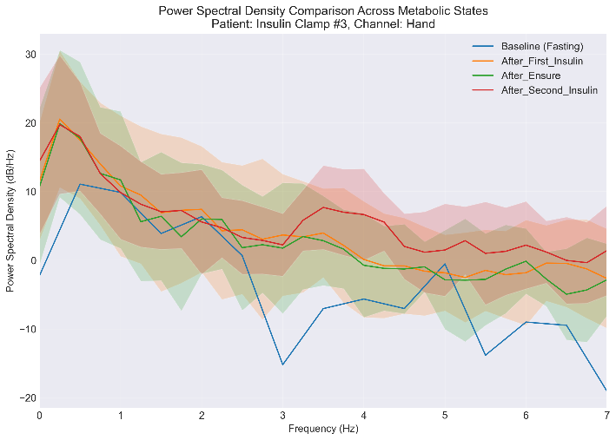

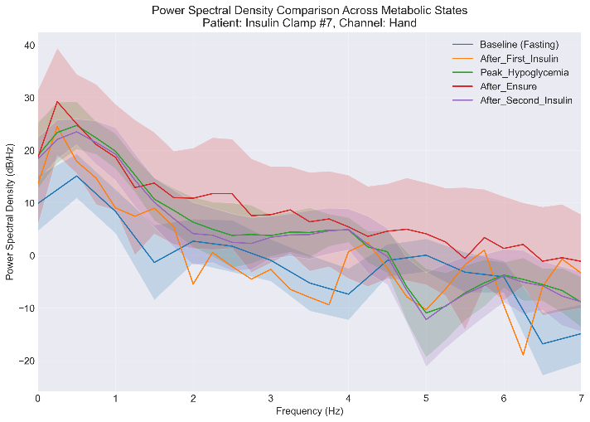

***Head Channel:***

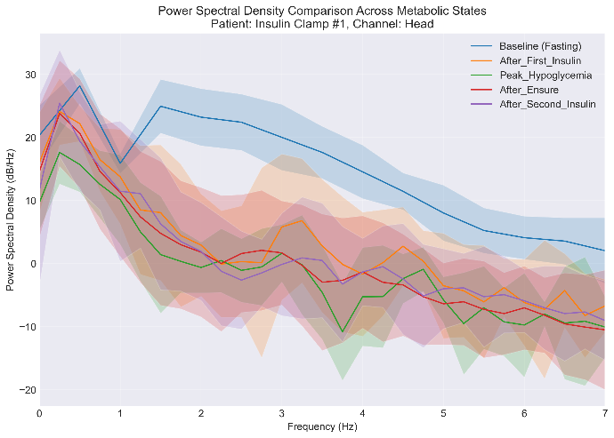

**Liver Channel:**

As one may see from the charts above, visually the power spectrum density is inconsistent across the channels and patients. On some of the charts we can technically spot the differences between the fine structure components of the spectrum, however these observations are not stationary across the entire dataset and can state either highly individual patterns across the individual patients/channels, or a stochastic nature of the signal, arising from motion artifacts.

Anyway, for the sake of formal evaluation we will proceed to numerical evaluation of these patterns *within* and *across* the patients.

**Classification assessment per patient/channel**We have assembled the metrics across the patients and channels, to have a formal assessment of the assumptions in the hypothesis. These metrics formally evaluate the hypothesis in every stated claim. Combined metric of 70% (true values) of the claims per state considered as a “strong” match to hypothesis.

|  |  |  |  |  |  |  |  |  |  |  |  |
| --- | --- | --- | --- | --- | --- | --- | --- | --- | --- | --- | --- |
| Metabolic State | Hypothesis Match | Match Level | Details | | | | | | | | Patient |
| Baseline (Fasting) | 75.00% | Moderate | dominant freq in 0 1Hz | True | single broad peak | True | stable amplitude | True | minimal high freq | False | Patient_1 |
| After_First_Insulin | 100.00% | Strong | broadened low freq peak | True | extra peaks 2 5Hz | True | lower amplitude | True |  |  | Patient_1 |
| Peak_Hypoglycemia | 100.00% | Strong | distinct high freq peaks | True | rhythmic pattern | True |  |  |  |  | Patient_1 |
| After_Ensure | 66.70% | Moderate | narrow peak | False | clean spectrum | True | minimal above 1Hz | True |  |  | Patient_1 |
| After_Second_Insulin | 66.70% | Moderate | mixed pattern | True | high low freq power | True | shallow mid freq peaks | False |  |  | Patient_1 |
| Baseline (Fasting) | 50.00% | Moderate | dominant freq in 0 1Hz | True | single broad peak | False | stable amplitude | False | minimal high freq | True | Patient_2 |
| After_First_Insulin | 100.00% | Strong | broadened low freq peak | True | extra peaks 2 5Hz | True | lower amplitude | True |  |  | Patient_2 |
| Peak_Hypoglycemia | 100.00% | Strong | distinct high freq peaks | True | rhythmic pattern | True |  |  |  |  | Patient_2 |
| After_Ensure | 33.30% | Weak | narrow peak | False | clean spectrum | False | minimal above 1Hz | True |  |  | Patient_2 |
| After_Second_Insulin | 66.70% | Moderate | mixed pattern | True | high low freq power | True | shallow mid freq peaks | False |  |  | Patient_2 |
| Baseline (Fasting) | 100.00% | Strong | dominant freq in 0 1Hz | True | single broad peak | True | stable amplitude | True | minimal high freq | True | Patient_3 |
| After_First_Insulin | 33.30% | Weak | broadened low freq peak | False | extra peaks 2 5Hz | True | lower amplitude | False |  |  | Patient_3 |
| Peak_Hypoglycemia |  | Unknown |  |  |  |  |  |  |  |  | Patient_3 |
| After_Ensure | 66.70% | Moderate | narrow peak | False | clean spectrum | True | minimal above 1Hz | True |  |  | Patient_3 |
| After_Second_Insulin | 66.70% | Moderate | mixed pattern | True | high low freq power | True | shallow mid freq peaks | False |  |  | Patient_3 |
| Baseline (Fasting) | 75.00% | Moderate | dominant freq in 0 1Hz | True | single broad peak | True | stable amplitude | False | minimal high freq | True | Patient_4 |
| After_First_Insulin | 66.70% | Moderate | broadened low freq peak | True | extra peaks 2 5Hz | True | lower amplitude | False |  |  | Patient_4 |
| Peak_Hypoglycemia |  | Unknown |  |  |  |  |  |  |  |  | Patient_4 |
| After_Ensure | 33.30% | Weak | narrow peak | False | clean spectrum | True | minimal above 1Hz | False |  |  | Patient_4 |
| After_Second_Insulin | 66.70% | Moderate | mixed pattern | True | high low freq power | True | shallow mid freq peaks | False |  |  | Patient_4 |
| Baseline (Fasting) | 50.00% | Moderate | dominant freq in 0 1Hz | True | single broad peak | False | stable amplitude | False | minimal high freq | True | Patient_5 |
| After_First_Insulin | 100.00% | Strong | broadened low freq peak | True | extra peaks 2 5Hz | True | lower amplitude | True |  |  | Patient_5 |
| Peak_Hypoglycemia |  | Unknown |  |  |  |  |  |  |  |  | Patient_5 |
| After_Ensure | 33.30% | Weak | narrow peak | False | clean spectrum | False | minimal above 1Hz | True |  |  | Patient_5 |
| After_Second_Insulin | 66.70% | Moderate | mixed pattern | True | high low freq power | True | shallow mid freq peaks | False |  |  | Patient_5 |
| Baseline (Fasting) | 75.00% | Moderate | dominant freq in 0 1Hz | True | single broad peak | True | stable amplitude | False | minimal high freq | True | Patient_6 |
| After_First_Insulin | 33.30% | Weak | broadened low freq peak | False | extra peaks 2 5Hz | True | lower amplitude | False |  |  | Patient_6 |
| Peak_Hypoglycemia | 100.00% | Strong | distinct high freq peaks | True | rhythmic pattern | True |  |  |  |  | Patient_6 |
| After_Ensure | 66.70% | Moderate | narrow peak | False | clean spectrum | True | minimal above 1Hz | True |  |  | Patient_6 |
| After_Second_Insulin | 66.70% | Moderate | mixed pattern | True | high low freq power | True | shallow mid freq peaks | False |  |  | Patient_6 |
| Baseline (Fasting) | 50.00% | Moderate | dominant freq in 0 1Hz | True | single broad peak | False | stable amplitude | False | minimal high freq | True | Patient_7 |
| After_First_Insulin | 66.70% | Moderate | broadened low freq peak | True | extra peaks 2 5Hz | True | lower amplitude | False |  |  | Patient_7 |
| Peak_Hypoglycemia | 50.00% | Moderate | distinct high freq peaks | True | rhythmic pattern | False |  |  |  |  | Patient_7 |
| After_Ensure | 33.30% | Weak | narrow peak | False | clean spectrum | True | minimal above 1Hz | False |  |  | Patient_7 |
| After_Second_Insulin | 66.70% | Moderate | mixed pattern | True | high low freq power | True | shallow mid freq peaks | False |  |  | Patient_7 |
| Baseline (Fasting) | 100.00% | Strong | dominant freq in 0 1Hz | True | single broad peak | True | stable amplitude | True | minimal high freq | True | Patient_8 |
| After_First_Insulin | 100.00% | Strong | broadened low freq peak | True | extra peaks 2 5Hz | True | lower amplitude | True |  |  | Patient_8 |
| Peak_Hypoglycemia |  | Unknown |  |  |  |  |  |  |  |  | Patient_8 |
| After_Ensure | 33.30% | Weak | narrow peak | False | clean spectrum | False | minimal above 1Hz | True |  |  | Patient_8 |
| After_Second_Insulin | 66.70% | Moderate | mixed pattern | True | high low freq power | True | shallow mid freq peaks | False |  |  | Patient_8 |
| Baseline (Fasting) | 75.00% | Moderate | dominant freq in 0 1Hz | True | single broad peak | False | stable amplitude | True | minimal high freq | True | Patient_9 |
| After_First_Insulin | 66.70% | Moderate | broadened low freq peak | True | extra peaks 2 5Hz | True | lower amplitude | False |  |  | Patient_9 |
| Peak_Hypoglycemia | 100.00% | Strong | distinct high freq peaks | True | rhythmic pattern | True |  |  |  |  | Patient_9 |
| After_Ensure | 33.30% | Weak | narrow peak | False | clean spectrum | True | minimal above 1Hz | False |  |  | Patient_9 |
| After_Second_Insulin | 66.70% | Moderate | mixed pattern | True | high low freq power | True | shallow mid freq peaks | False |  |  | Patient_9 |
| Baseline (Fasting) | 75.00% | Moderate | dominant freq in 0 1Hz | True | single broad peak | True | stable amplitude | True | minimal high freq | False | Patient_10 |
| After_First_Insulin | 33.30% | Weak | broadened low freq peak | False | extra peaks 2 5Hz | True | lower amplitude | False |  |  | Patient_10 |
| Peak_Hypoglycemia |  | Unknown |  |  |  |  |  |  |  |  | Patient_10 |
| After_Ensure | 33.30% | Weak | narrow peak | False | clean spectrum | True | minimal above 1Hz | False |  |  | Patient_10 |
| After_Second_Insulin | 66.70% | Moderate | mixed pattern | True | high low freq power | True | shallow mid freq peaks | False |  |  | Patient_10 |

Hypothesis Metrics Calculation Methods are a direct translation of hypothesis assumptions to signal processing language:

“Baseline (Fasting)” Metrics:

- **dominant freq. range**: Identifies the frequency with maximum power in the spectrum to determine if it falls within 0-1Hz

- **peak width**: Measures the broadness of the main spectral peak by calculating half-width at a percentage of maximum height

- **amplitude stability**: Quantifies signal consistency by calculating the mean standard deviation across segments in the 0-1Hz band

- **high freq. content**: Calculates the ratio of power in frequencies above 1Hz to power in 0-1Hz band

“After First Insulin” Metrics:

- **low freq. peak width**: Measures the width of the low-frequency peak and compares it to baseline width

- **extra peaks 2-5Hz**: Counts the number of distinct peaks detected in the 2-5Hz frequency range

- **amplitude reduction**: Calculates the ratio of average power compared to baseline state

"Peak Hypoglycemia" Metrics:

- **high freq. peaks**: Counts the number of peaks detected in the 2-7Hz range

- **rhythmicity**: Uses autocorrelation of the PSD to measure periodicity of high-frequency components

“After Ensure” Metrics:

- **peak narrowness**: Measures the width of the main peak and determines if it's narrower than baseline

- **spectral purity**: Calculates the ratio of power concentrated in main peak (±0.2Hz) to total power

- **activity above 1Hz**: Computes the ratio of average power above 1Hz to average power below 1Hz

After Second Insulin Metrics:

- **mixed pattern**: Boolean indicating presence of peaks in both low (0-1.5Hz) and mid (2-5Hz) frequency ranges

- **low freq. power**: Calculates average spectral power in the low frequency range (0-1.5Hz)

- **mid freq. power**: Calculates average spectral power in the mid frequency range (2-5Hz)

**“Specificity” Analysis within the patient data**

We have Evaluated how uniquely identifiable each state is using classification metrics, using the threshold-based classification to test discriminative power of each pattern  
Within this method we have analyzed the discriminative power of the frequency pattern hypotheses by:  
  
Testing Each State as a Classification Target:  
 - For each metabolic/glycemic state (e.g., "Baseline (Fasting)", "Peak_Hypoglycemia")  
 - Treating that state as the "positive" class, while all other states are treated as the "negative" class  
  
Calculating Key Classification Metrics:  
 - Specificity: How well the hypothesis avoids false positives (not misidentifying other states)  
 - Sensitivity: How well the hypothesis correctly identifies the target state  
 - Precision: Proportion of positive identifications that are correct  
 - F1 Score: Harmonic mean of precision and sensitivity  
 - Accuracy: Overall correctness of identification

This analysis could potentially help determine whether each metabolic/glycemic state has a truly distinctive spectral signature by quantifying:  
- Which states have the most unique frequency patterns  
- Which states might be confused with each other  
- The overall reliability of using frequency patterns for state identification

Detailed metrics are available for every channel and patient outside the scope of this report.

Here is an example of specificity and F1 score for Hand channel across the patients:

|  |  |  |  |  |  |
| --- | --- | --- | --- | --- | --- |
| Patient | Spec_After_Ensure | Spec_After_First_Insulin | Spec_After_Second_Insulin | Spec_Baseline (Fasting) | Spec_Peak_Hypoglycemia |
| Patient_1 | 0.25 | 0.50 | 0.25 | 0.50 | 0.50 |
| Patient_2 | 0.50 | 0.75 | 0.50 | 0.50 | 0.75 |
| Patient_3 | 0.75 | 0.75 | 0.75 | 1.00 | 0.75 |
| Patient_4 | 0.75 | 0.75 | 0.75 | 1.00 | 0.75 |
| Patient_5 | 0.75 | 1.00 | 0.75 | 0.75 | 0.75 |
| Patient_6 | 0.50 | 0.50 | 0.50 | 0.75 | 0.75 |
| Patient_7 | 1.00 | 1.00 | 1.00 | 1.00 | 1.00 |
| Patient_8 | 0.50 | 0.75 | 0.50 | 0.75 | 0.50 |
| Patient_9 | 0.50 | 0.50 | 0.50 | 0.75 | 0.75 |
| Patient_10 | 0.75 | 0.75 | 0.75 | 1.00 | 0.75 |
| Average | **0.63** | **0.73** | **0.63** | **0.80** | **0.73** |

|  |  |  |  |  |  |
| --- | --- | --- | --- | --- | --- |
| Patient | F1 Baseline (Fasting) | F1 After_First_Insulin | F1 Peak_Hypoglycemia | F1 After_Ensure | F1 After_Second_Insulin |
| Patient_1 | 0.50 | 0.50 | 0.50 | 0.00 | 0.00 |
| Patient_2 | 1.00 | 0.00 | 0.00 | 0.00 | 0.00 |
| Patient_3 | 0.00 | 0.67 | 0.67 | 0.00 | 0.00 |
| Patient_4 | 1.00 | 0.00 | 0.00 | 0.00 | 0.00 |
| Patient_5 | 1.00 | 0.00 | 0.00 | 0.00 | 0.00 |
| Patient_6 | 0.00 | 1.00 | 0.00 | 0.00 | 0.00 |
| Patient_7 | 0.67 | 0.00 | 0.67 | 0.00 | 0.00 |
| Patient_8 | 0.00 | 0.00 | 0.00 | 0.00 | 0.00 |
| Patient_9 | 0.67 | 0.67 | 0.00 | 0.00 | 0.00 |
| Patient_10 | 0.67 | 0.00 | 0.67 | 0.00 | 0.00 |
| Average | **0.55** | **0.28** | **0.25** | **0.00** | **0.00** |

As one may see from the tables above, in-patient specificity is mostly average, and F1-scores are much below average.

**Cross-Patient Validation**

Theoretically, the cross-patient validation shall answer the question: "Are these frequency patterns consistent biomarkers that generalize across different patients?”

Cross-patient validation has been done by means of statistical analysis ACROSS patients by:

* Calculating consistency metrics (means, standard deviations, coefficients of variation)
* Quantifying how reliably patterns appear across different subjects
* Creating visualizations specifically showing inter-patient variability
* Categorizing states by consistency level (High/Medium/Low)
* remark – these are still quasi-metrics rather than established clinical validation metrics. The cross-patient validation uses custom statistical measures instead of standard clinical validation methods.

Here are some visualizations of these metrics:

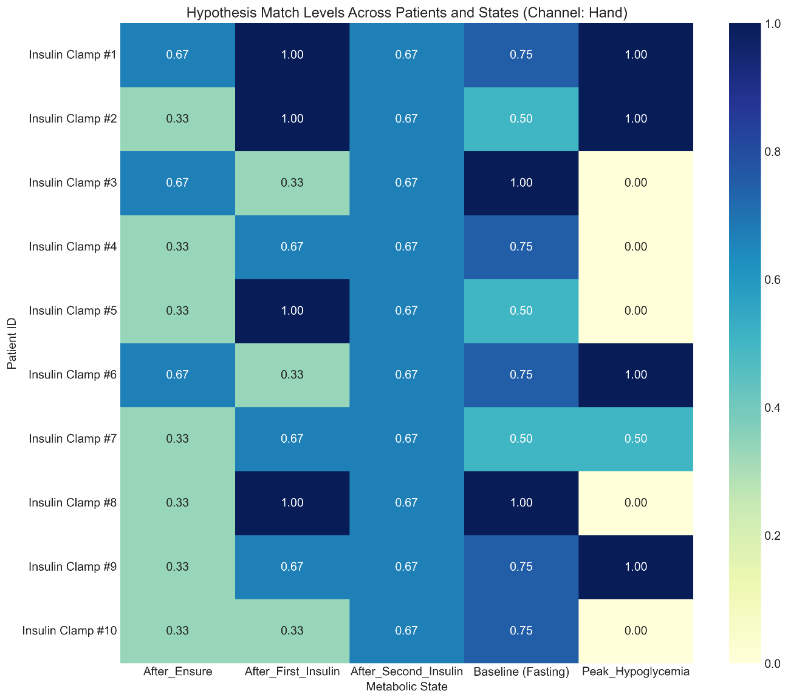

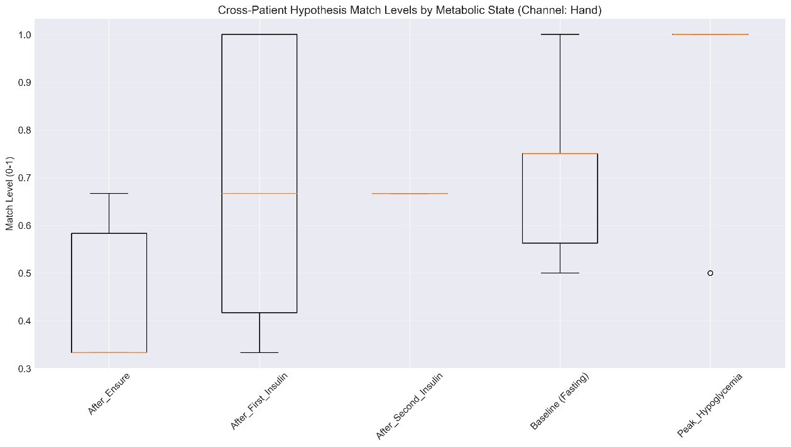

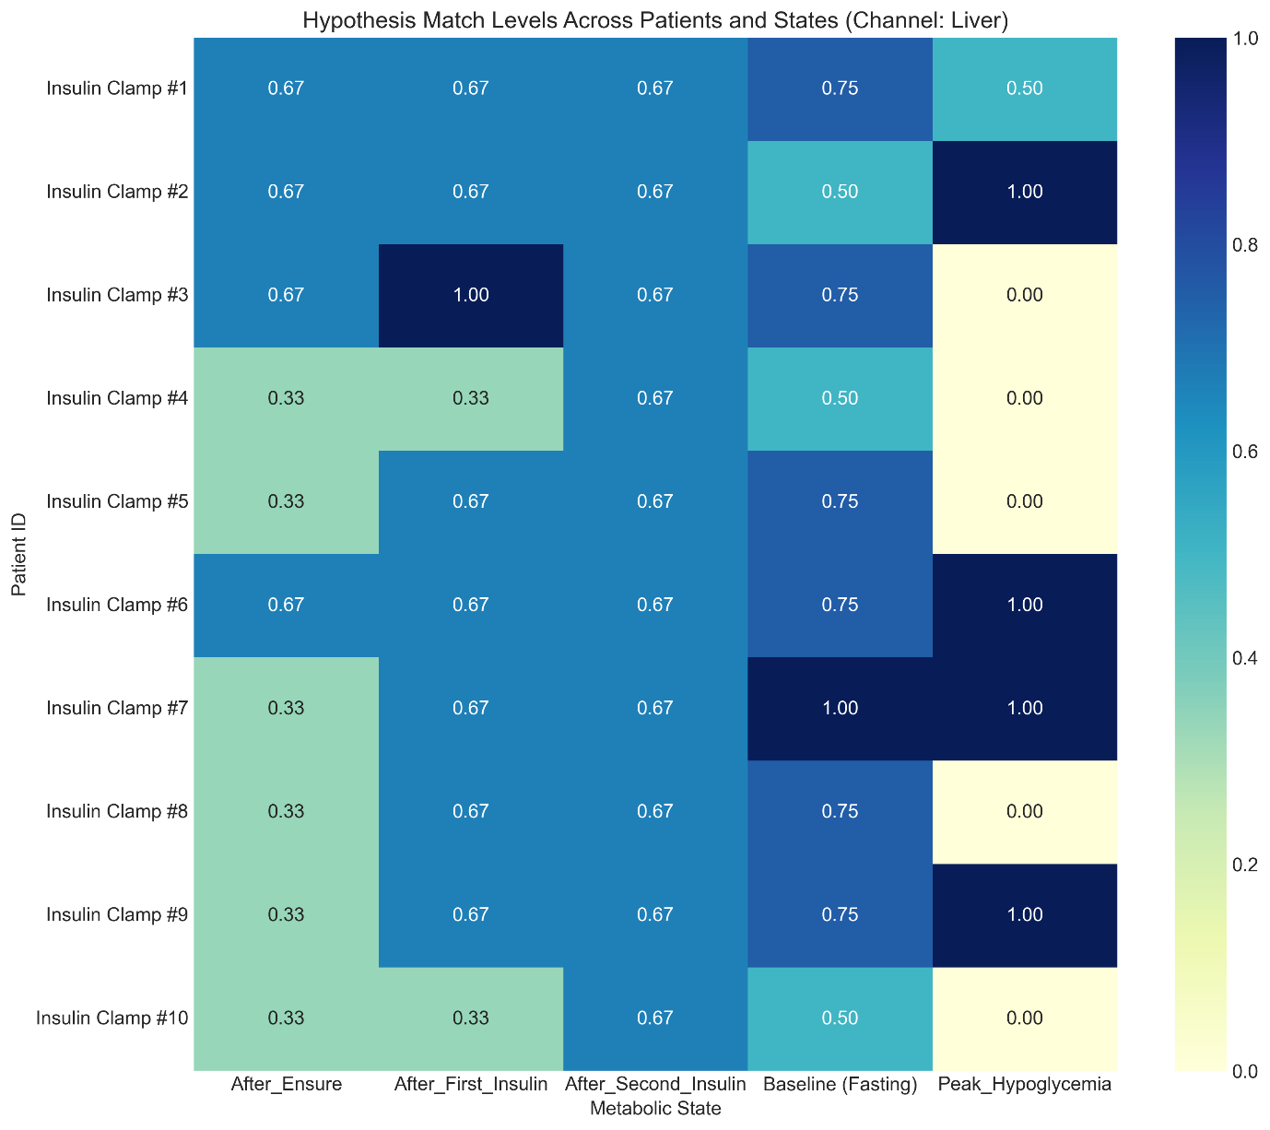 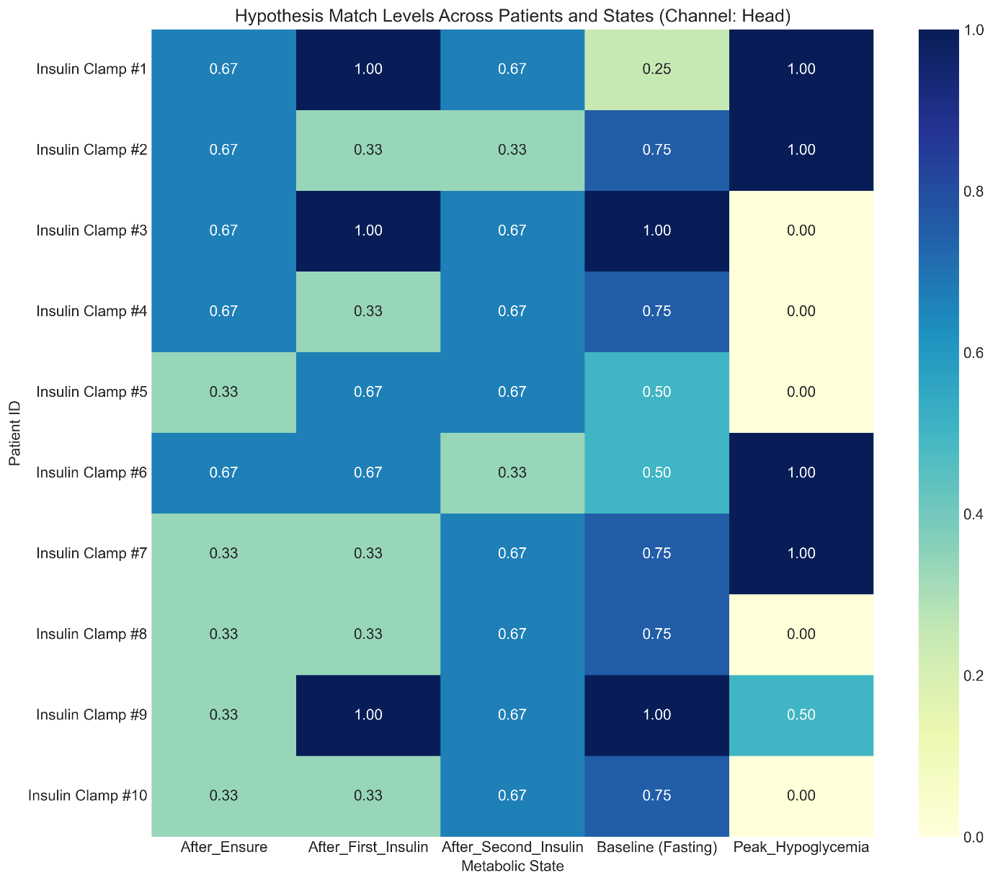

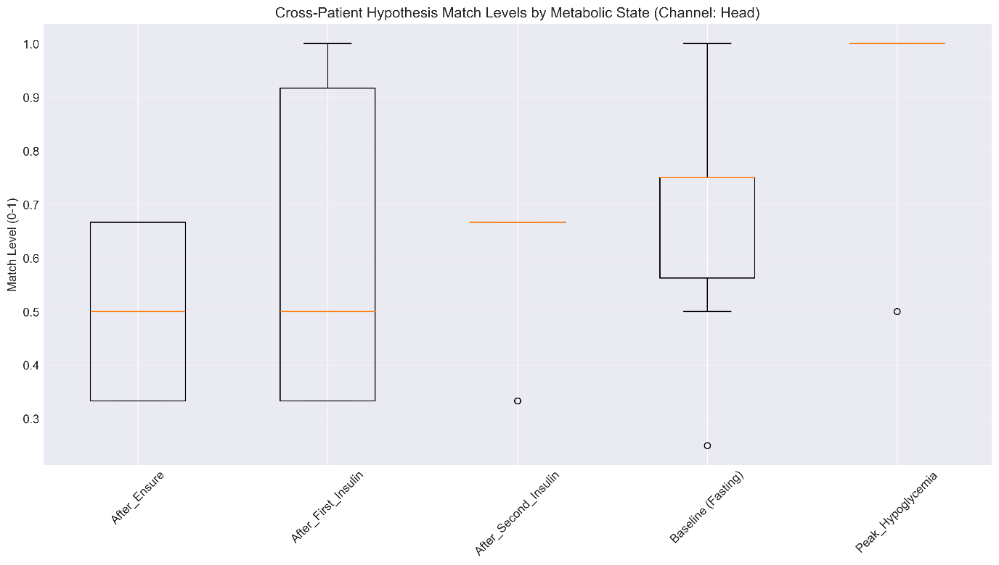

|  |  |  |  |  |
| --- | --- | --- | --- | --- |
| Hand: | | | | |
| Metabolic State | Mean Match | Std Dev | CV | Level |
| After_Ensure | 43.30% | 15.30% | 35.30% | Medium |
| After_First_Insulin | 70.00% | 27.70% | 39.60% | Medium |
| After_Second_Insulin | 66.70% | 0.00% | 0.00% | High |
| Baseline (Fasting) | 72.50% | 17.50% | 24.10% | Medium |
| Peak_Hypoglycemia | 90.00% | 20.00% | 22.20% | Medium |
| Head: | | | | |
| After_Ensure | 50.00% | 16.70% | 33.30% | Medium |
| After_First_Insulin | 60.00% | 29.10% | 48.40% | Low |
| After_Second_Insulin | 60.00% | 13.30% | 22.20% | Medium |
| Baseline (Fasting) | 70.00% | 21.80% | 31.10% | Medium |
| Peak_Hypoglycemia | 90.00% | 20.00% | 22.20% | Medium |
| Liver: | | | | |
| After_Ensure | 46.70% | 16.30% | 35.00% | Medium |
| After_First_Insulin | 63.30% | 18.00% | 28.30% | Medium |
| After_Second_Insulin | 66.70% | 0.00% | 0.00% | High |
| Baseline (Fasting) | 70.00% | 15.00% | 21.40% | Medium |
| Peak_Hypoglycemia | 90.00% | 20.00% | 22.20% | Medium |

**Cross-Patient Validation Results Analysis**

Most Consistent Patterns

1. Formally “Peak Hypoglycemia” shows the strongest pattern recognition (90% match) across all channels, though only present in half the patients, but it is an artifact of broad definition (distinct high-frequency peaks)

2. Same story with “After Second Insulin” state. It shows high consistency (0% coefficient of variation in Hand/Liver channels), with uniform 66.7% match rates. This could have indicated a very reliable but moderate-strength pattern, but and again – seems like a result of broad definition

- Mixed pattern signature detection

- Power distribution across low and mid-frequency bands

3. Baseline (Fasting): Shows good consistency across all channels (70-72.5% match) with medium variability between patients. This seems to be true, since it is a typical pink noise pattern

Most Variable Patterns

1. “After First Insulin” shows high variability between patients, especially in Head recordings (CV 48.4%). The heatmaps reveal some patients show perfect matches (1.0) while others show poor matches (0.33). If we recall the definition (Broadened low-freq peak, extra peaks 2-5Hz, lower amplitude) it seems reasonable.

2. “After Ensure”: Consistently shows the weakest match levels (43-50%) across all channels. This suggests the hypothesized "narrow peak, clean spectrum" pattern is less reliable.

Channel Comparison

- “Hand” channel generally shows the most consistent results

- “Head” channel shows highest variability between patients

- Excluding the “Peak Hypoglycemia” (not presenting in all the cases) , no channels agree a strongest pattern, but do agree on a weakest pattern (“After Ensure”)

**Bottom Line**

Based on the findings above, the results suggest that frequency patterns, that hypothetically could serve as biomarkers for certain metabolic states, are probably random and the visible differences arise from motion artifacts, that could be related to hypoglycemia induced tremors, affecting the magnetic sensor